Name:

Block:
Independent/Dependent Variable practice HW

MY assignment: Section A Section B Section C

Section A

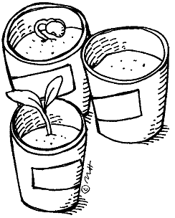
- Jose wants to find out what kind of music helps plants grow the best. He decides to grow bean plants, and decides he wants to test them growing in Rap, Country, Classical, and Hard Rock. He grows 5 plants in each different kind of music, and then measures how tall the bean plants grow over one week.

  - What were the different things he tested? (IV)

  - What did he measure for his results to see which music was the best? (DV)

- Cynthia wants to find out what drug helps get rid of headaches the fastest. She gets 5 volunteers and asks them to take Advil, Tylenol, Aspirin, or Alleve for their headaches over the next few months. They then have to rate how bad their headache is one hour after they take their medicine.

  - What were the different things she tested? (IV)

  - What did she measure for her results to see which drug was the best? (DV)

Section B

- If you wanted to test what helps plants grow the fastest, what are some examples of Independent Variables that you could test? What are some examples of Dependent Variables that you could measure?

Possible IVs:

Possible DVs:

- If you wanted to find out what helps dogs learn the best, what are some examples of Independent Variables that you could test? What are some examples of Dependent Variables that you could measure?

Possible IVs:

Possible DVs:

Section C on back
Section C

- In experiments, it is important to have only ONE independent variable at a time. WHY? What would happen in the experiment if you had more than one IV at a time? (You may use the scenarios in Section A to give examples, or use your own, but justify your answer with a specific examples.)

- Why is it ok to have more than one Dependent Variable in an experiment at the same time? Again, justify your answer using a specific example.

